Kafka Architecture

- Core Architecture
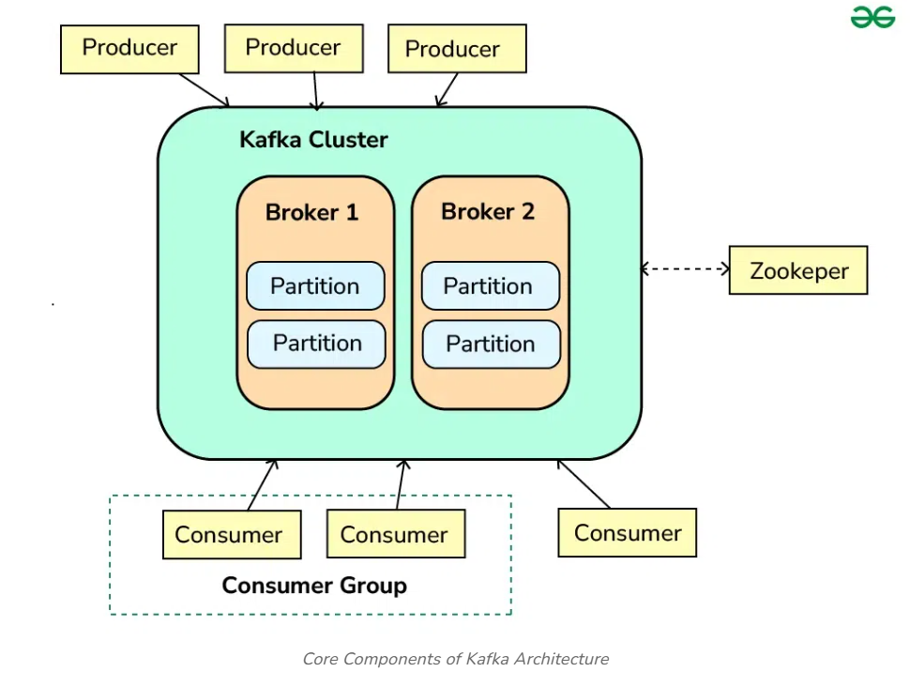

- Broker
Broker is a kafka server (stores data, manages partitions) which contains topics partition.

- Producer
Producers are client applications that publish (write) data to Kafka topics. They send records to the appropriate topic and partition based on the partitioning strategy, which can be key-based or round-robin.

- Consumer
Consumers are client applications that subscribe to Kafka topics and process the data. They read records from the topics and can be part of a consumer group, which allows for load balancing and fault tolerance. Each consumer in a group reads data from a unique set of partitions.
Kafka allows:
- 🔹 Any number of consumer groups per topic.
- 🔹 Any number of consumer groups per broker.
- 🔹 replication factor cannot be more than brokers.
rf <= no. of brokers

- Kafka Topic
Data in Kafka is organized into topics, which are logical channels to which producers send data and from which consumers read data.
- A topic is like a logical category or a stream of messages (e.g., orders, payments).
- Producers write (publish) messages into a topic.
- Consumers read (subscribe) from the topic.

- Partitions
Each topic is divided into partitions, which are the basic unit of parallelism in Kafka. Partitions allow Kafka to scale horizontally by distributing data across multiple brokers.
- Each topic is split into partitions (like buckets).
- Partitioning gives parallelism and scalability.
- Example: Topic orders with 3 partitions (0, 1, 2).
👉 When a producer sends a message:
- Kafka decides which partition the message goes to.
- Partition choice can be based on:
  - Keyed message → hash(key) % number_of_partitions
  - Round-robin (if no key is provided)
  - Custom partitioner (user-defined logic)
So:
- Message with key user1 may always go to partition 0.
- Message with key user2 may go to partition 1.

- Offset
Offsets are unique identifiers assigned to each message in a partition. Consumers will use these offsets to track their progress in consuming messages from a topic.
Inside a partition, messages are stored in append-only order.
Each message is assigned a unique offset (a sequential number).
Offsets start from 0 in each partition and keep increasing.
👉 Example (Partition 0):
Offset 0 → "Order Created"
Offset 1 → "Order Paid"
Offset 2 → "Order Shipped"
Offsets are not global, they are per partition.

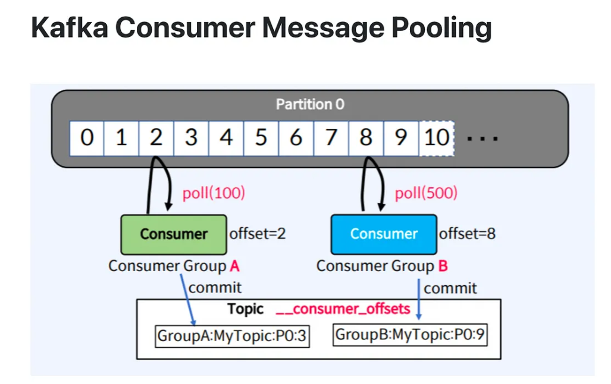
_counser_offsets (default topic) will store all consumer-groups and consumer offset_number.
consumer-groups or consumer reads message from any partition of topic.

- Zookeeper
ZooKeeper is a centralized service for maintaining configuration information, naming, providing distributed synchronization, and providing group services. In Kafka, ZooKeeper is used to manage and coordinate the Kafka brokers. ZooKeeper is shown as a separate component interacting with the Kafka cluster.

How Consumer Reads
- Consumers keep track of offsets to know what they have already processed.
- Kafka doesn’t delete messages right after consumption. Instead:
- Consumer stores its last committed offset.
- If a consumer restarts, it can continue from the last offset.
- This enables replay (re-read old data) and fault-tolerance.

Putting It All Together
- Producer writes a message → Kafka assigns it to a partition.
- Kafka appends it at the end of the partition log with a unique offset.
- Consumer reads messages in order of offsets and commits progress.

📌 Example: Topic = orders, 2 partitions

Partition 0:
Offset 0: "order-101 created"
Offset 1: "order-102 created"

Partition 1:
Offset 0: "order-201 created"
Offset 1: "order-202 created"

- Producer with key 101 → always goes to partition 0.
- Consumer Group → balances partitions among consumers.

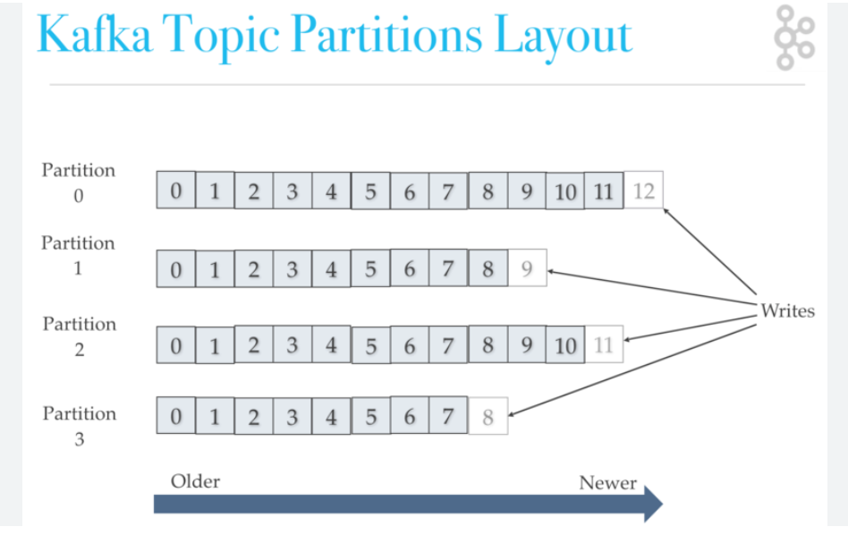

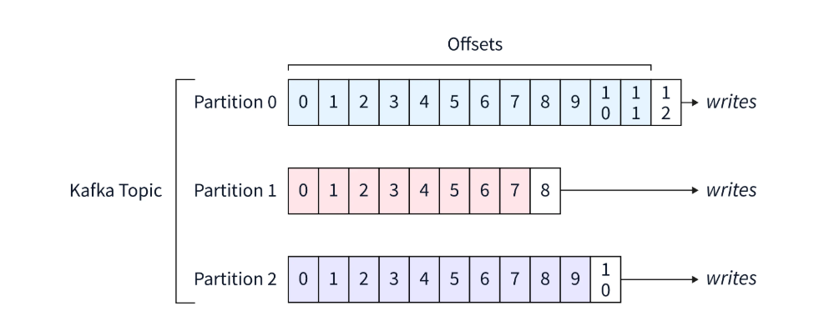

- Question: Can Kafka broker1 has topic1, topic2 and topic3 and broker2 has topic3, topic4?
Answer: In Kafka, topics are not stored entirely on one broker. Instead:
- Topics are split into partitions.
- Partitions are distributed across multiple brokers.
- So, you won’t see something like “Broker-1 has Topic-1”. Instead, you’ll see “Broker-1 has some partitions of Topic-1”.
Example
Say we have 2 brokers and 2 topics:
- Topic1 → 2 partitions
- Topic2 → 2 partitions
- Topic3 → 2 partitions
- Topic4 → 2 partitions

Possible Partition Placement
Broker-1:
Topic1: Partition-0 (Leader)
Topic2: Partition-0 (Follower)
Topic3: Partition-0 (Leader)
Topic4: Partition-1 (Follower)
Broker-2:
Topic1: Partition-1 (Leader)
Topic2: Partition-1 (Leader)
Topic3: Partition-1 (Follower)
Topic4: Partition-0 (Leader)
- Topic3 spans both brokers (P0 on Broker-1, P1 on Broker-2).
- Topic4 also spans both brokers.
- Brokers don’t “own” a whole topic; they host partitions of topics.
- Broker-1 and Broker-2 each store some partitions of Topic-1, Topic-2, Topic-3, Topic-4.
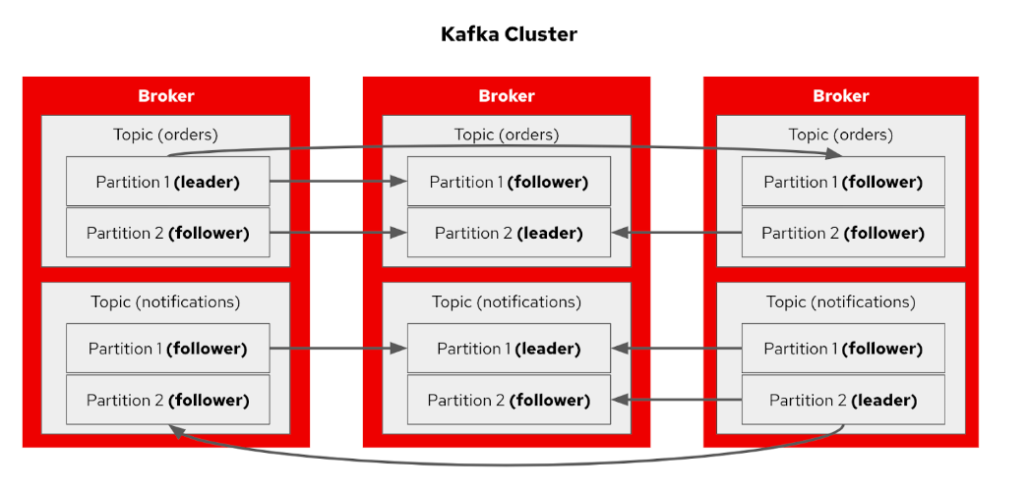

- Question: 7 broker, 3 topic and 3 replicas
Answer: Note: replication factor cannot be more than brokers. 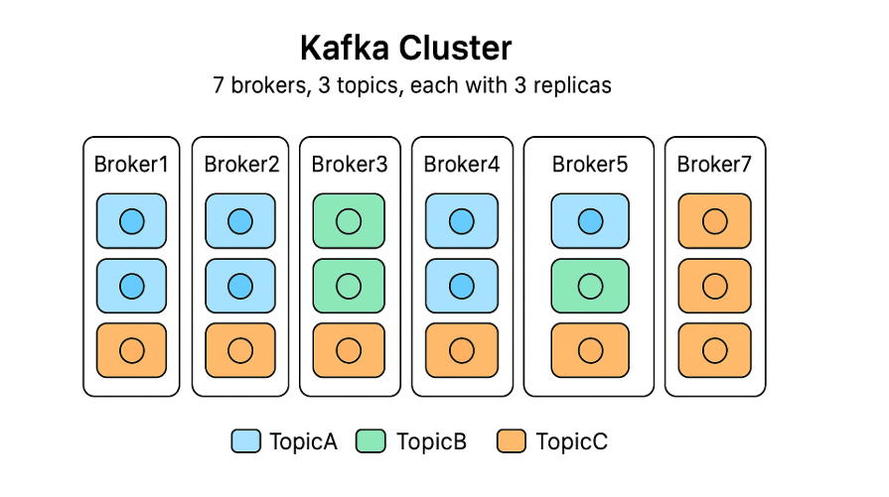

Question: single consumer group can read messages from multiple topics and their partitions?
Answer: Yes
📘 Example:
🔹 Topics:
- orders → 3 partitions
- payments → 2 partitions
🔹 Consumer group:
group-A
🔹 Consumers:
- consumer-1
- consumer-2

Kafka will assign partitions like:
Consumer | Topic | Partitions
consumer-1 | orders | 0, 1
consumer-1 | payments | 0
consumer-2 | orders | 2
consumer-2 | payments | 1

Question: one partition cannot be consumed by two consumers in the same consumer group at the same time.
Answer: ❌ No
❌ Invalid state:
Topic: 1 partition (P0)
Consumer Group: group-A
Consumers: C1, C2
P0 → C1
P0 → C2 ❌

Kafka stores offsets per consumer group per partition.
If two consumers read the same partition:
- Both would try to commit offsets
- This would cause data loss or duplicate processing

Question: one partition cannot be consumed by two consumers in the Multiple consumer groups at the same time.
Answer: ✔️ Yes
Question: How to Increase Parallelism processing in kafka
If you need more parallel processing, you have these options:
✅ Option 1: Increase Partitions (Most Common)
Partitions = 10
Consumers = 10
✅ Option 2: Parallel Processing Inside Consumer
- Use thread pools
- Process messages asynchronously after polling
✅ Option 3: Multiple Consumer Groups
- Same data, different processing logic
- Common in microservices

🧠 Summary Table
Scenario | Allowed?
1 partition → 2 consumers (same group) | ❌ No
1 partition → 2 consumers (different groups) | ✅ Yes
2 partitions → 2 consumers (same group) | ✅ Yes
10 partitions → 15 consumers (same group) | ✅ Yes (5 idle)

